Geojson script

The geojson script will turn a csv ordered in a specific way in to a geojson file which can be used to put as a layer over a map. The script can be changed to suit new formats or added columns but for the moment I have it so that it will work for Swedish vending machines for Nutrimino. If you are looking to recreate the Nutrimino geojson exactly follow these steps

(I have included the python file with comments if you would like to adjust the script.)

1. Open the example csv and change the format of your csv to match this

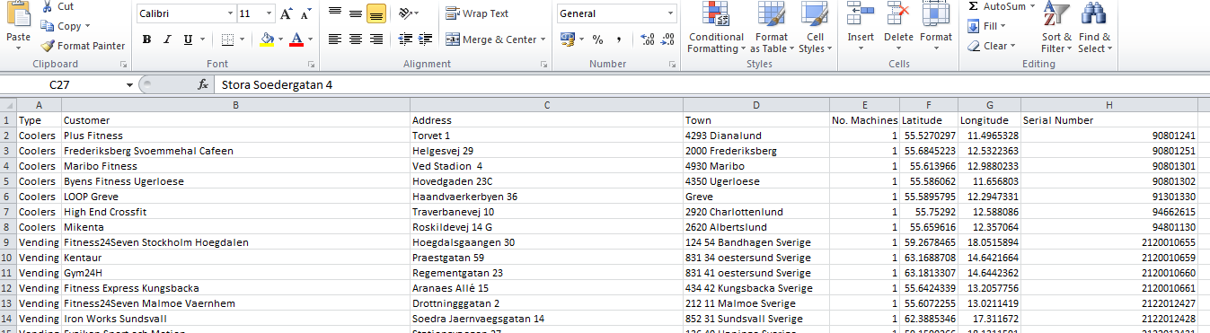

Please make sure your csv data is in the exact same format as shown above i.e. latitude and longitude in columns F and G. It does not matter what the header names are as long as the data is in this format.

Once you are happy the data is in order run the geojson.exe script

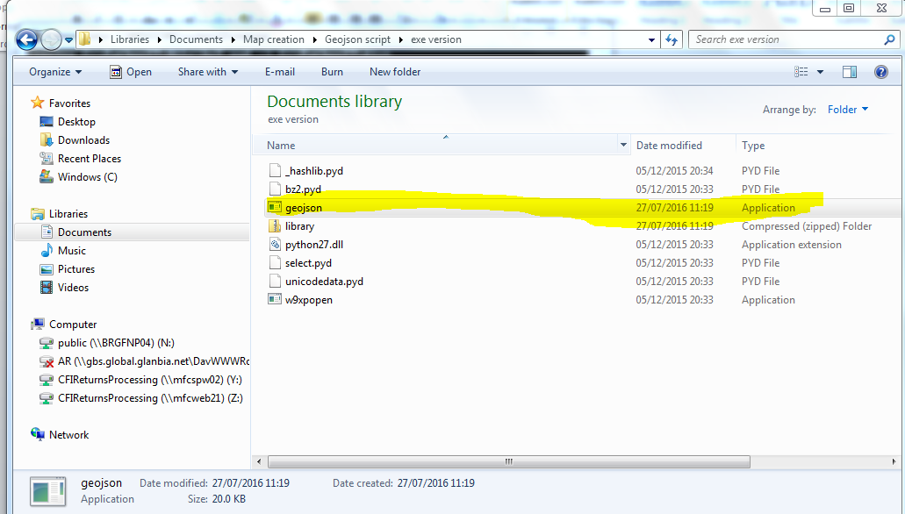

The script will ask you to what is the name of the csv file. This is where you input the relative path to your file or if it’s in the same directory just input the name of the csv file.

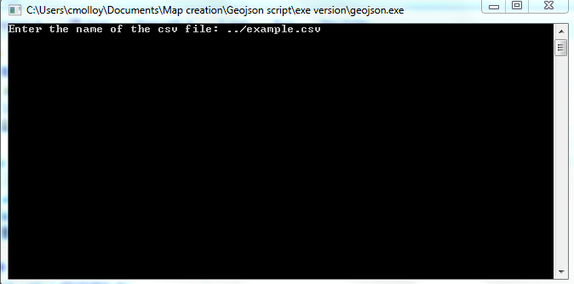

Press enter and the script will run and output a geojson.geojson file which is ready to be used on a map.

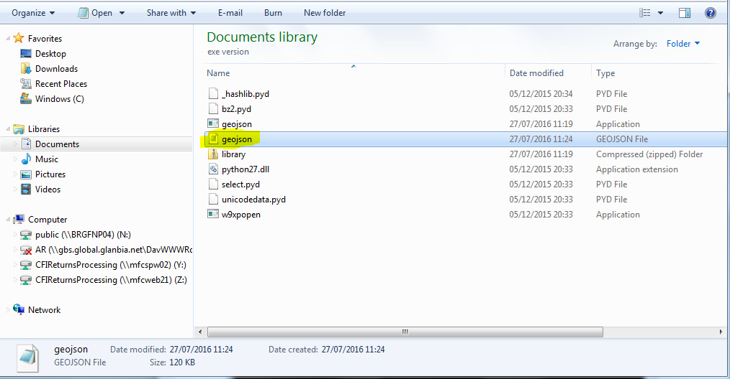

This is what the geojson file should look like.

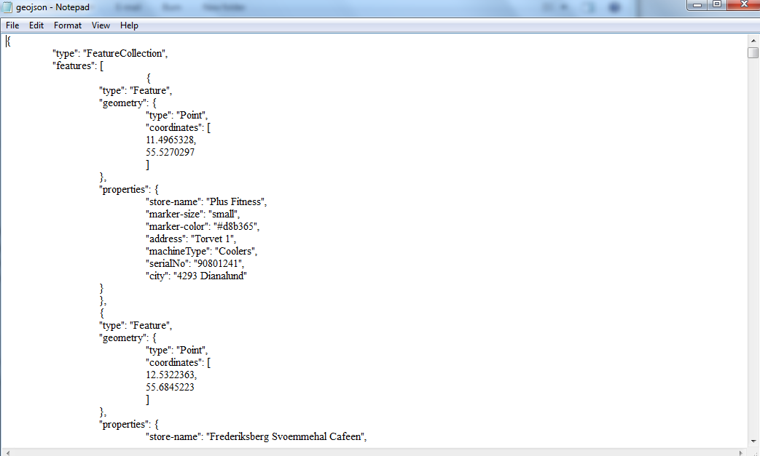

3) To include the new geojson file in to the map open the index.html file in a text editor of your choosing. Look after the HTML section to the JavaScript where you should find a variable that looks like the below with a load of text after it.

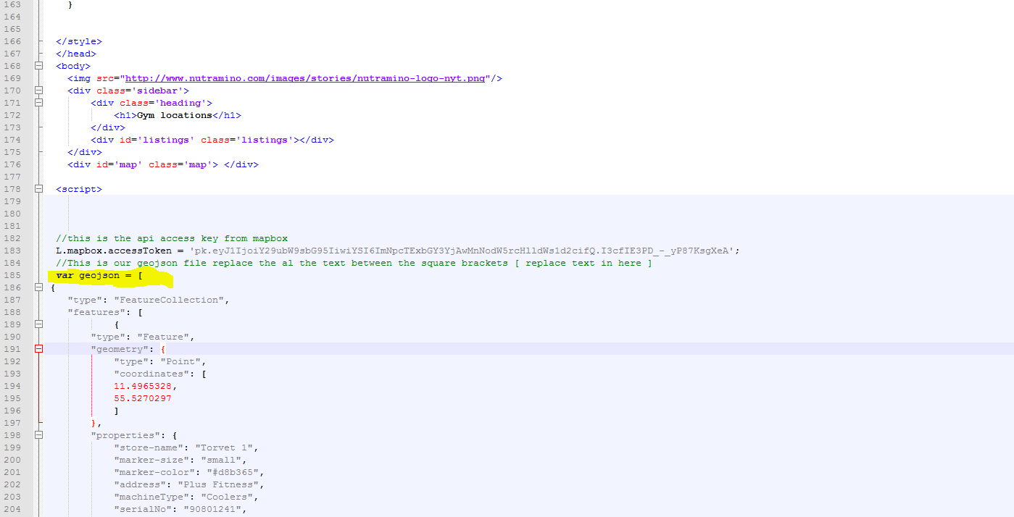

Copy the text from the geojson.geojson file and paste it between the square brackets of the

var geojson = [ some text ]

Save and open the index.html in the browser to make sure the new data appears.